**Practical 1**

**Make a Time Table Layout using HTML Tags**

**­**<html>

<head>

<title> Time Table </title>

</head>

<body>

    <table border="1">

        <tr>

            <th colspan="6">Time Table</th>

        </tr>

        <tr>

            <th colspan="1" rowspan="6">Hours</th>

            <th>Mon</th>

            <th>Tue</th>

            <th>Wed</th>

            <th>Thu</th>

            <th>Fri</th>

        </tr>

        <tr>

            <td>Maths</td>

            <td>Science</td>

            <td>Maths</td>

            <td>science</td>

            <td>Arts</td>

        </tr>

        <tr>

            <td>Maths</td>

            <td>Science</td>

            <td>Maths</td>

            <td>Science</td>

            <td>Arts</td>

        </tr>

        <tr>

            <td colspan="5" style=text-align: center;>lunch</td>

        </tr>

        <tr>

            <td>Maths</td>

            <td>Science</td>

<td>Maths</td>

<td colspan="2" rowspan="2" style=text-align: center;>project</td>

</tr>

        <tr>

            <td>Maths</td>

            <td>Science</td>

            <td>Maths</td>

        </tr>

</body>

</html>

**Output:-**

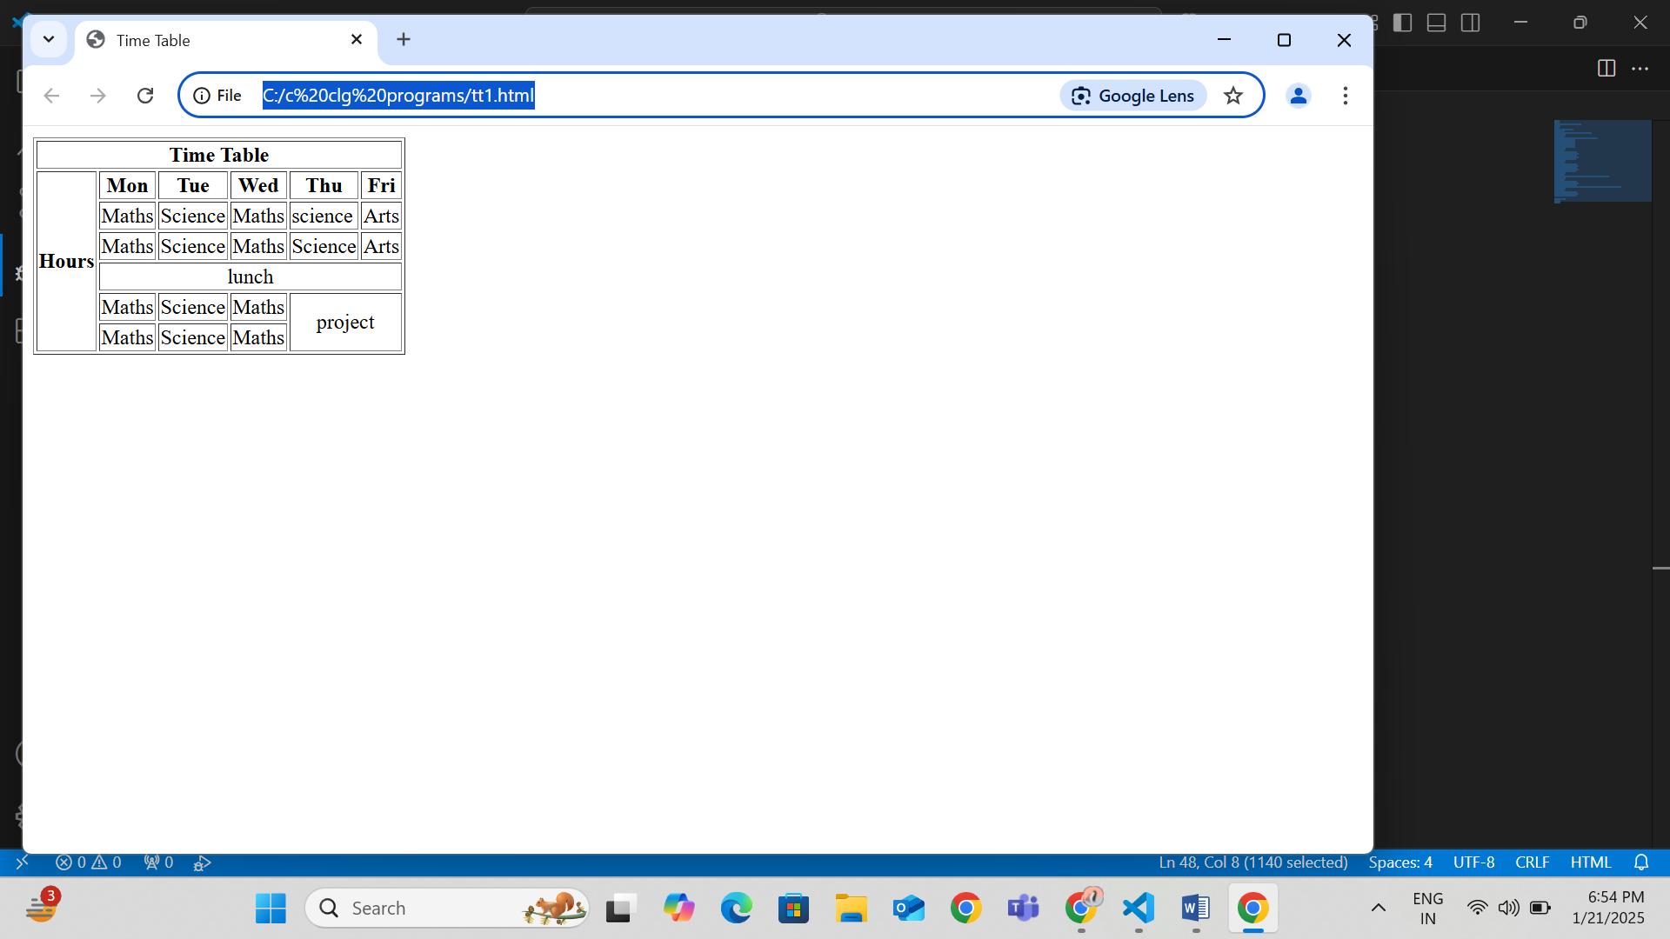

**Output:**

|  |  |  |  |  |  |
| --- | --- | --- | --- | --- | --- |
| **Time Table** | | | | | |
| **Hours** | **Mon** | **Tue** | **Wed** | **Thu** | **Fri** |
| Maths | Science | Maths | science | Arts |
| Maths | Science | Maths | Science | Arts |
| lunch | | | | |
| Maths | Science | Maths | project | |
| Maths | Science | Maths |

***Practical-2***

***Make a Time Table Layout using HTML Tags***

<<html>

<head>

  <title> Time Table</title>

  </head>

  <body>

    <h3 style="text-align: center;">TIME TABLE</h3>

    <table border="1" style=margin: align="center";">

    <tr>

      <th> Day/period</th>

      <th> 1<br>9:30-10:20</th>

      <th>2<br>10:20-11:10 </th>

      <th>3<br>11:10-12:00</th>

      <th>4<br>12:00-12:40</th>

      <th>5<br>12:40-1:30</th>

      <th>6<br>1:30-2:20</th>

      <th>7<br>2:20-3:10</th>

      <th>8<br>3:10-4:00</th>

      </tr>

        <tr>

          <td>Monday</td>

          <td>English</td>

          <td>Maths</td>

          <td>Chemistry</td>

          <td rowspan="5" style=text-align: center;>Lunch</td>

          <td colspan="3">Lab</td>

          <td>Play</td>

        </tr>

        <tr>

          <td>Tuesday</td>

          <td colspan="3">Lab</td>

          <td>English</td>

          <td>Chemistry</td>

          <td>Maths</td>

          <td>Sports</td>

        </tr>

        <tr>

<td>Wednesday</td>

          <td>Maths</td>

          <td>Play</td>

          <td>English</td>

          <td>Chemistry</td>

          <td colspan="3">Library</td>

        </tr>

        <tr>

          <td>Thursday</td>

          <td>Play</td>

          <td>English</td>

          <td>Chemistry</td>

          <td colspan="3">Lab</td>

          <td>Maths</td>

        </tr>

        <tr>

          <td>Friday</td>

          <td>Play</td>

          <td>English</td>

          <td>Chemistry</td>

          <td colspan="3">Lab</td>

          <td>Maths</td>

        </tr>

      </body>

    </html>

**Output:-**

**Time Table**

|  |  |  |  |  |  |  |  |  |
| --- | --- | --- | --- | --- | --- | --- | --- | --- |
| **Day/period** | **1 9:30-10:20** | **2 10:20-11:10** | **3 11:10-12:00** | **4 12:00-12:40** | **5 12:40-1:30** | **6 1:30-2:20** | **7 2:20-3:10** | **8 3:10-4:00** |
| Monday | English | Maths | Chemistry | Lunch | Lab | | | Play |
| Tueday | Lab | | | English | Chemistry | Maths | Sports |
| Wednesday | Maths | Play | English | Chemistry | Library | | |
| Thusday | Play | English | Chemistry | Lab | | | Maths |
| Friday | Play | English | Chemistry | Lab | | | Maths |

